**Accessing AWS**

**AWS Can be Accessed via AWS Console, Command Line and API.**

**Lab 1: Accessing AWS via AWS Console**

This Lab will provide the various ways of accessing AWS Cloud:

Step 1: Login to the AWS Console

<https://console.aws.com>

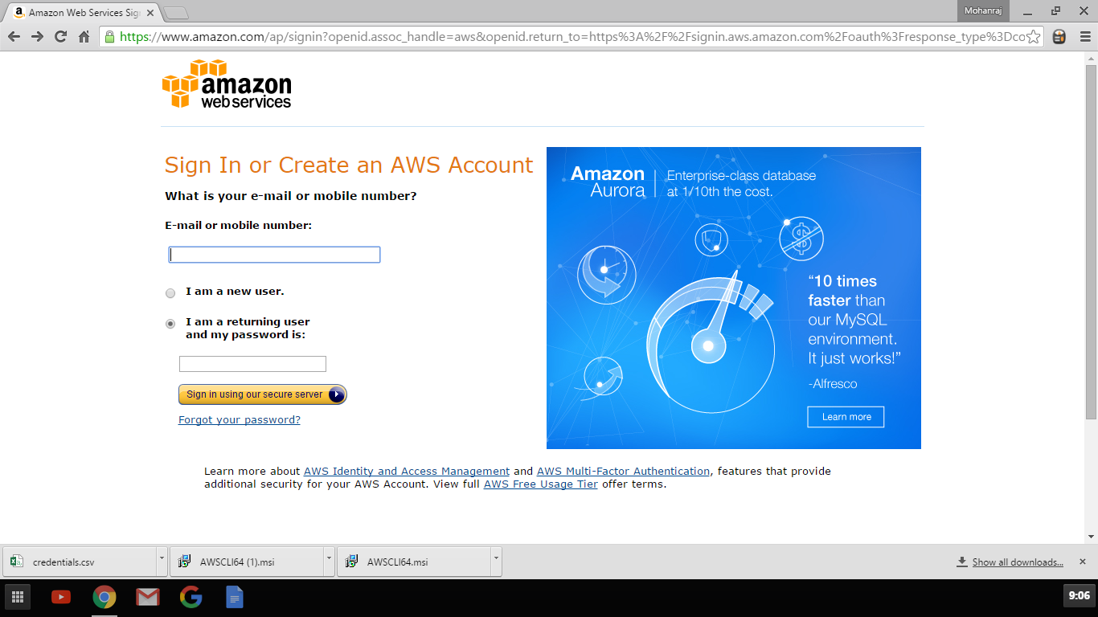

Access Home button to access all Services

Home button

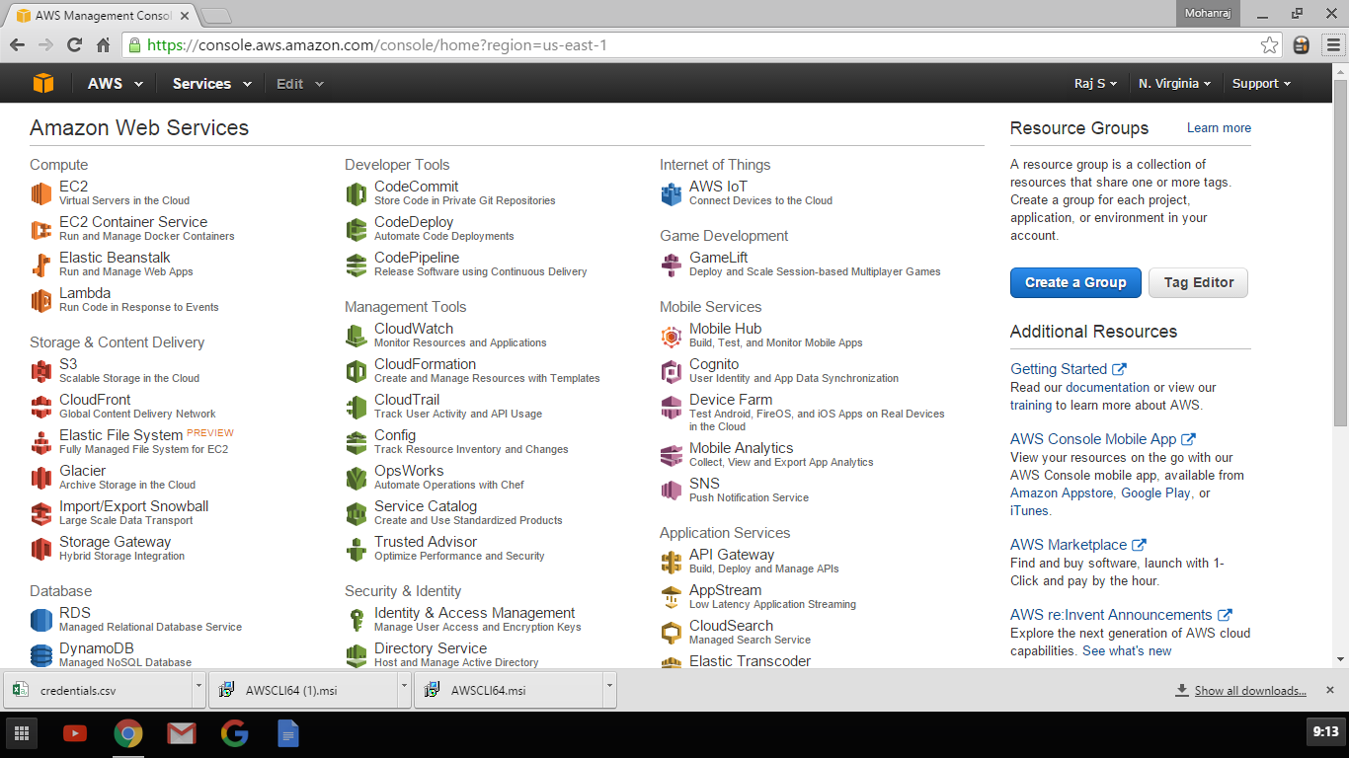

Resource Group will be useful for Grouping the resources we will see this later

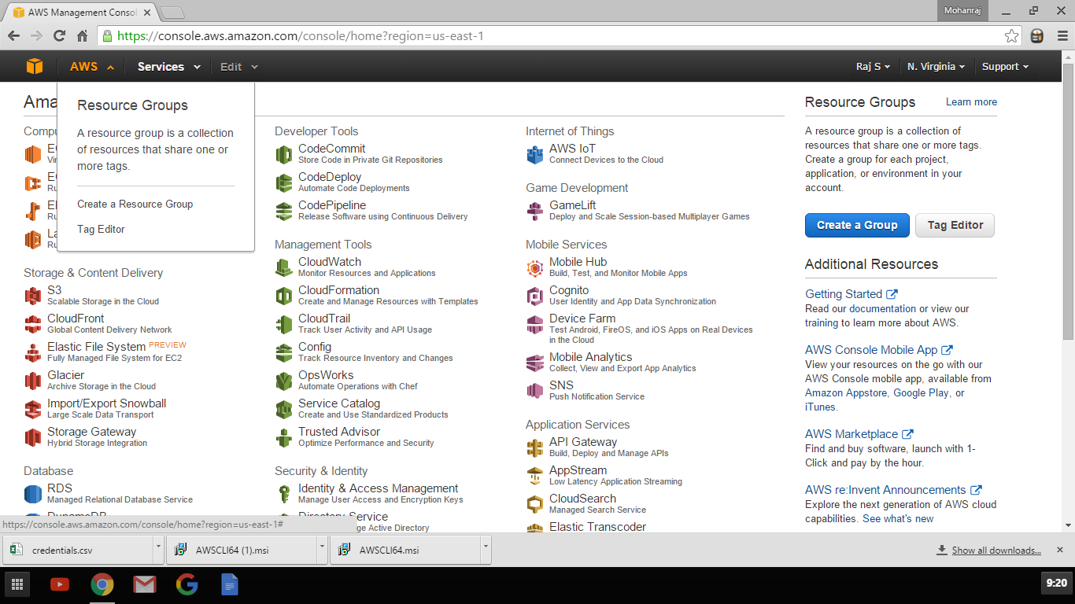

Services Tab list all the Services

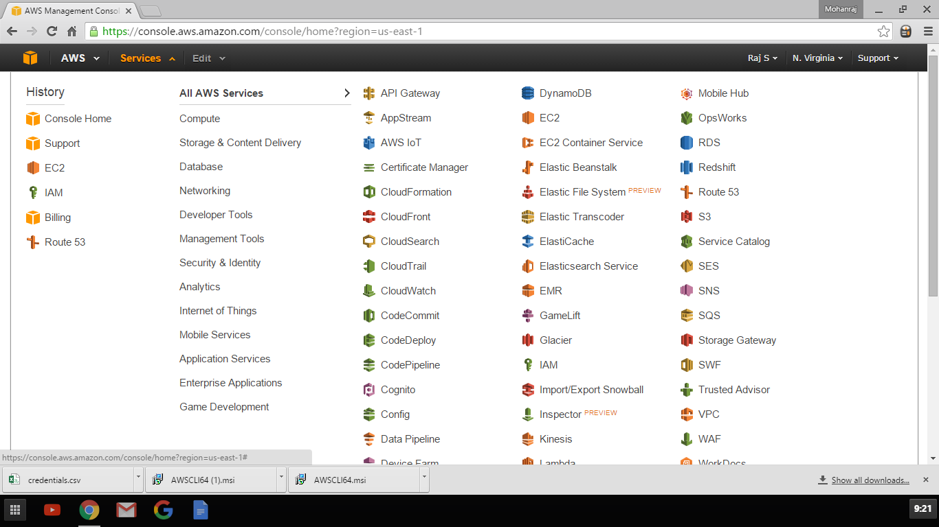

Edit Screen to Drag and Drop services in Top bar for easy access

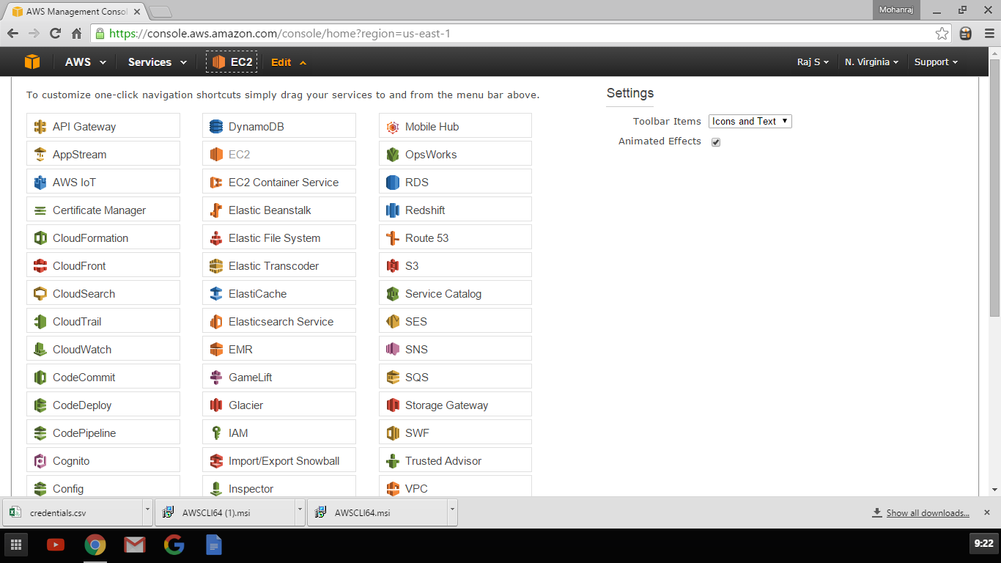

Click on the Name to access your account Click My Account to access your account details

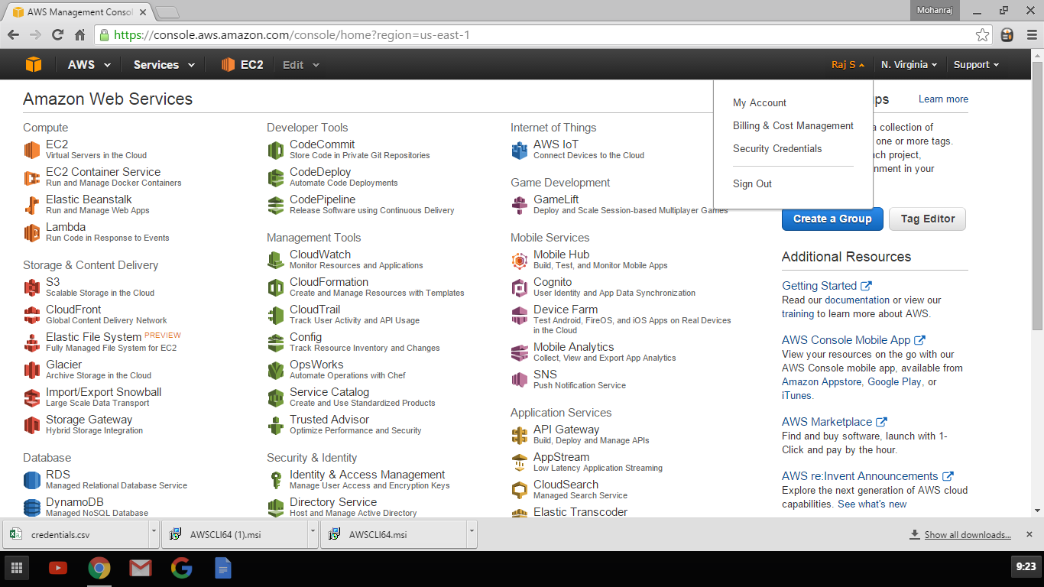

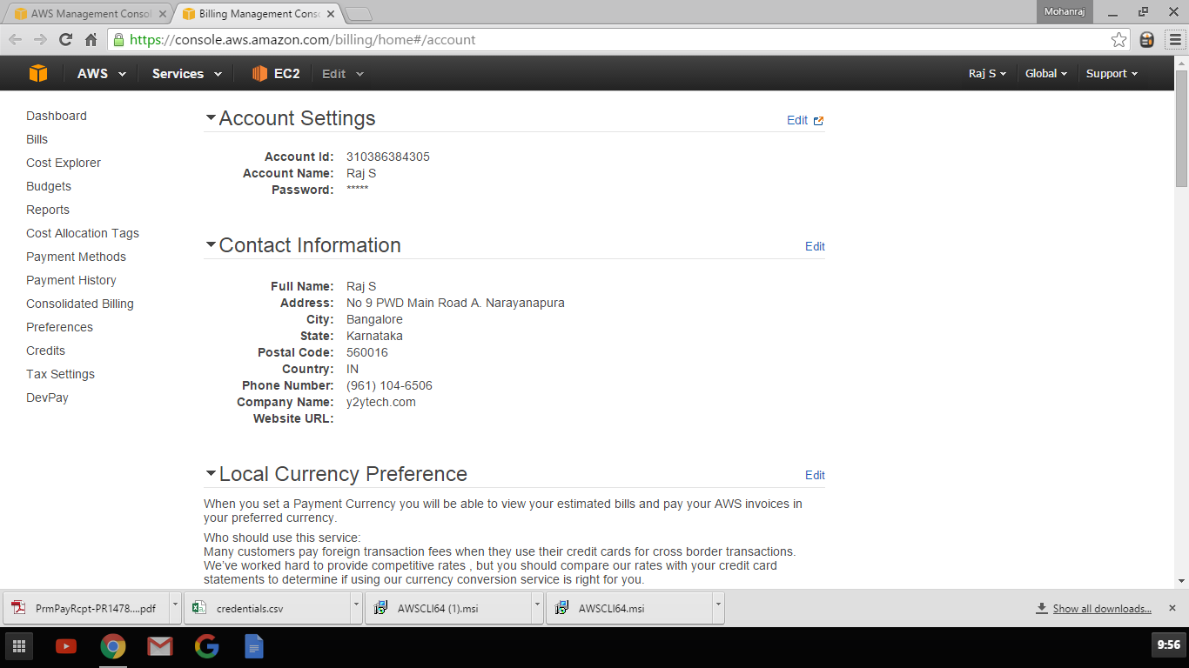

Change Currency to be billed

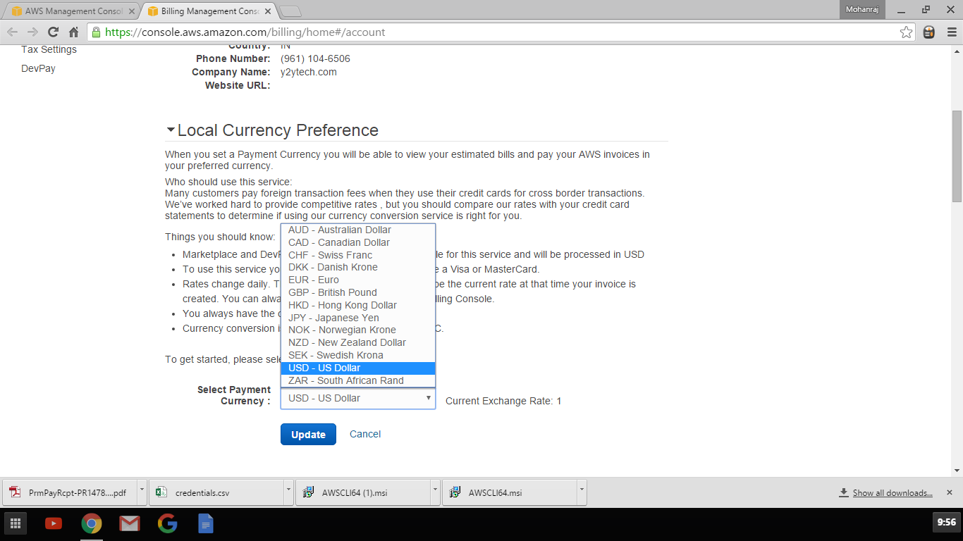

Alternative Contacts

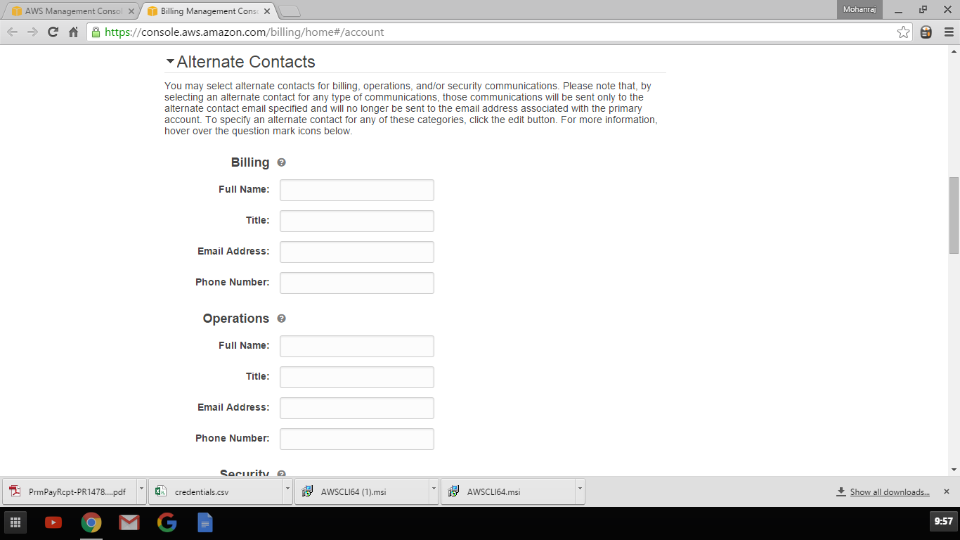

Setup Security questions

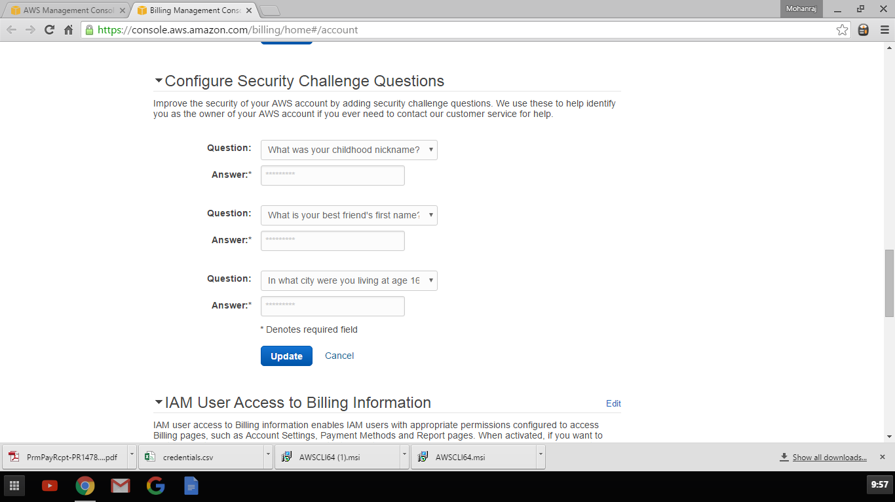

Enable IAM Users to Billing Information

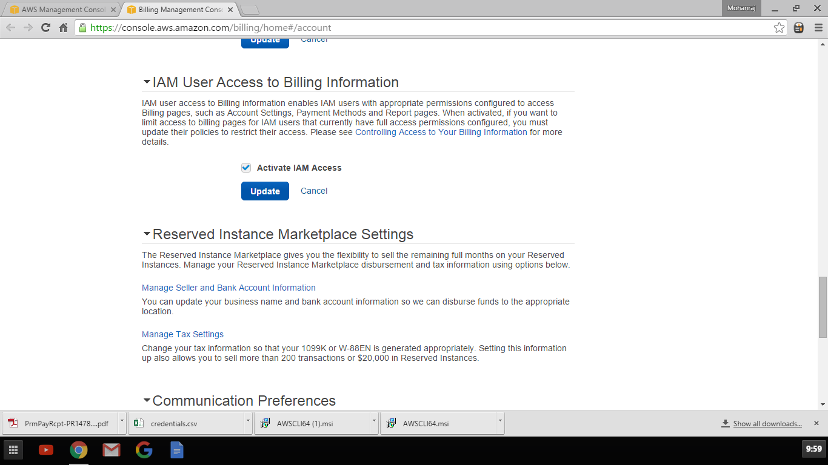

Cancel Service or close account

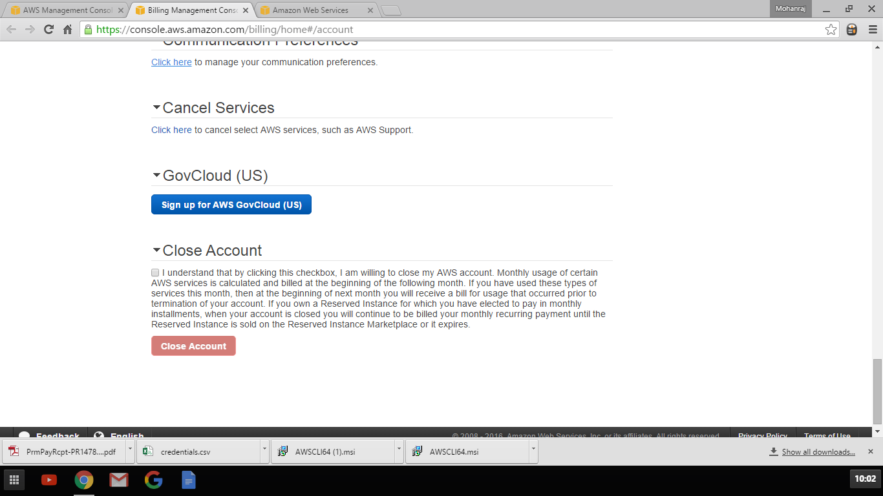

Click Billing and Cost Management for Billing Information

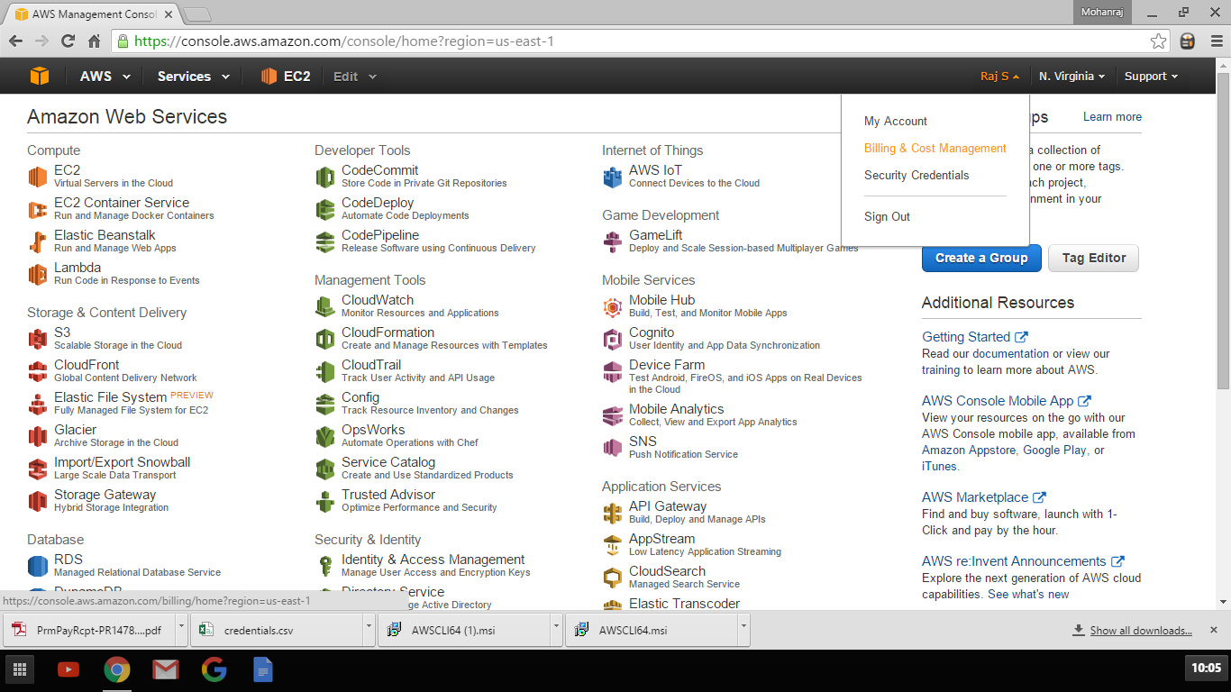

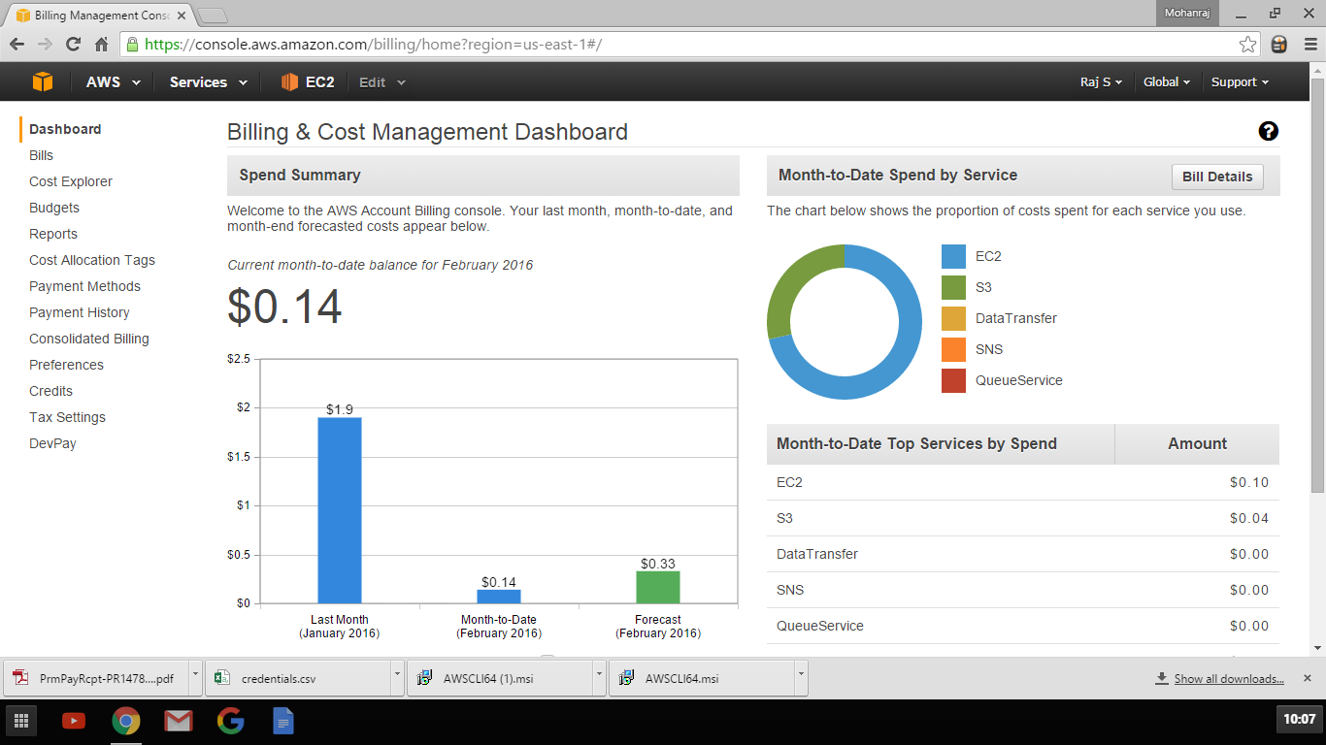

Billing Information

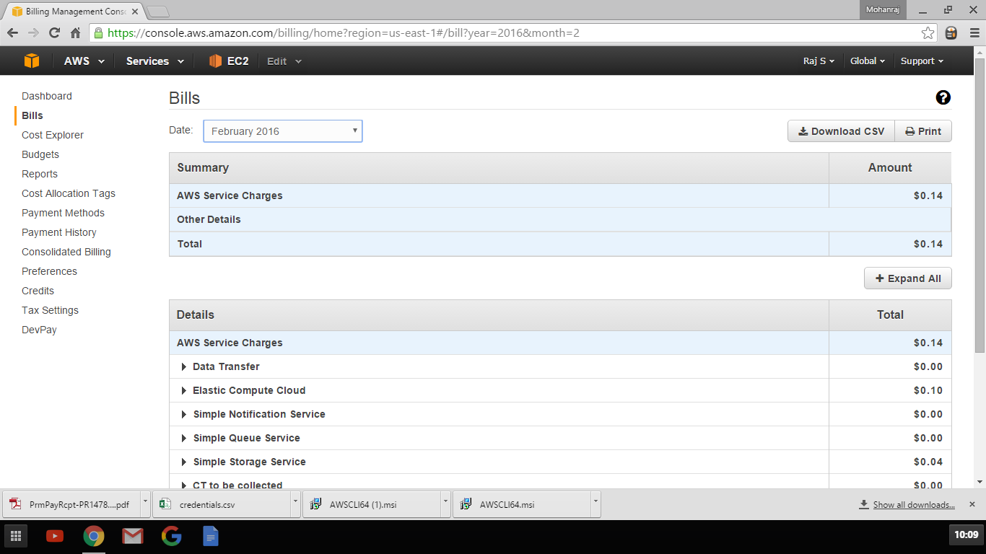

Enable Cost explorer

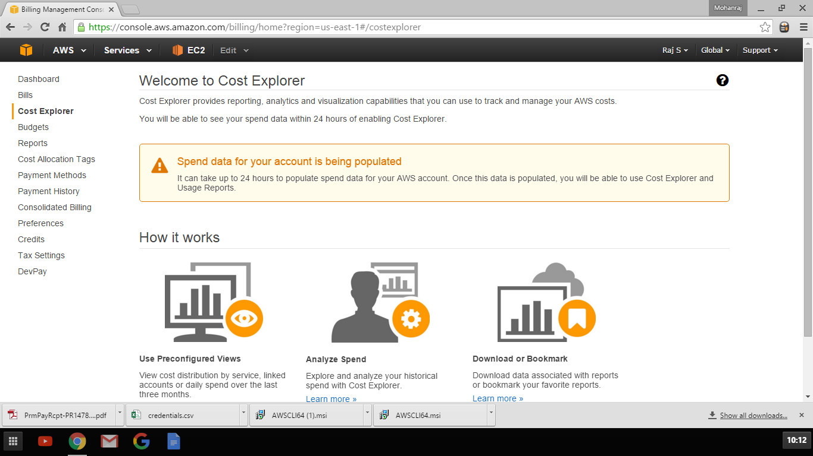

Create Budget Notification

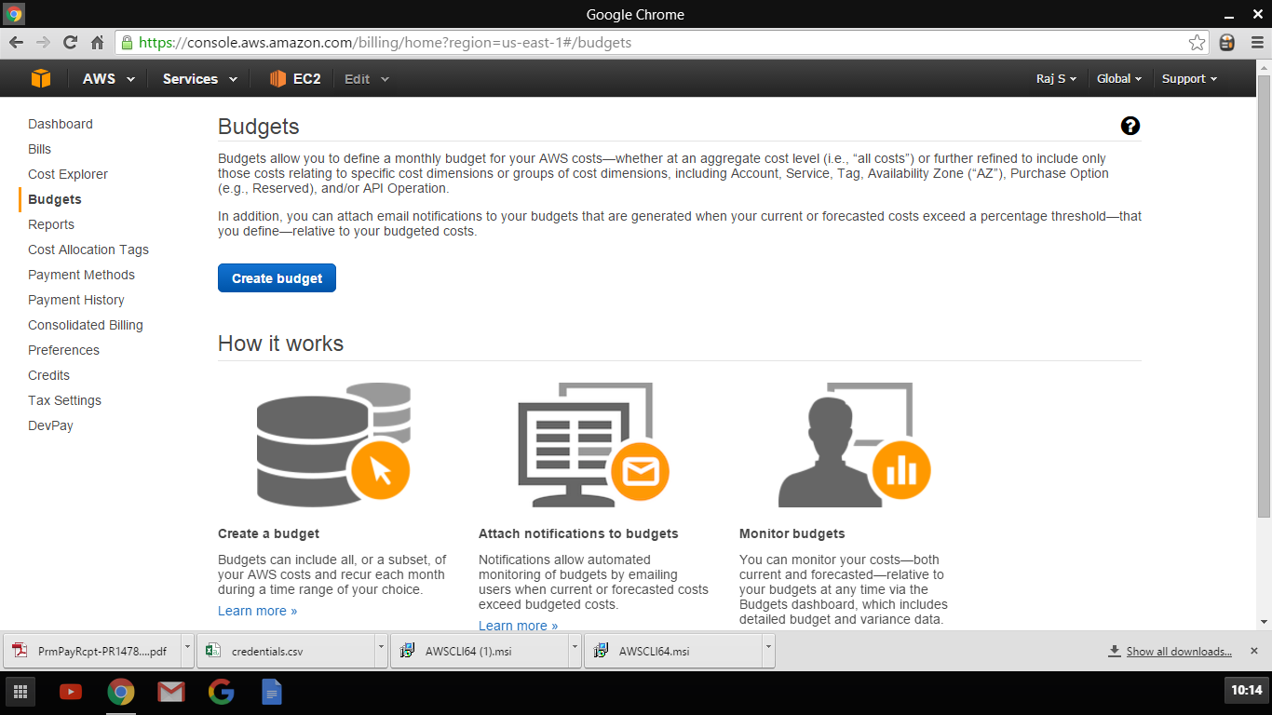

Create Usage Reports

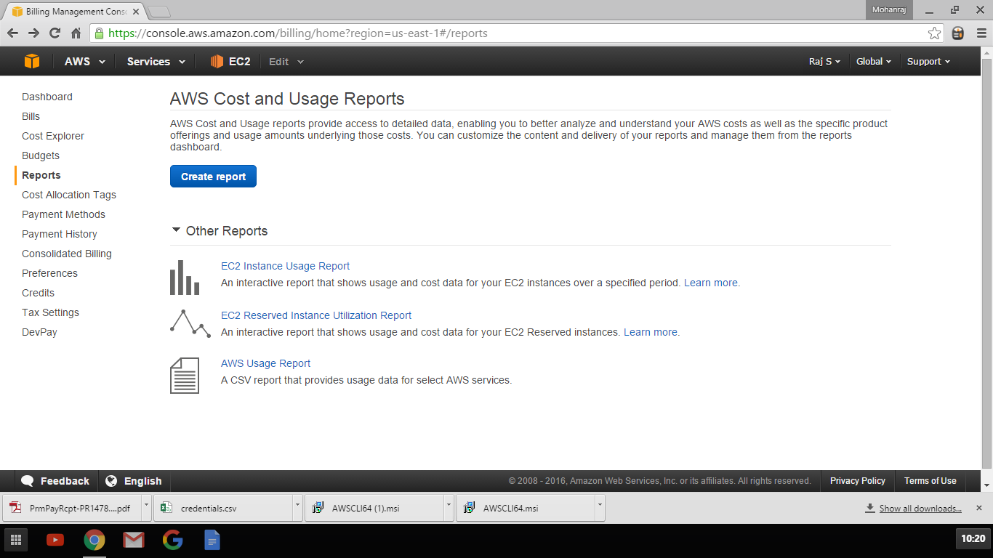

Explore other Payment options

Select Region you want to view or create resources on

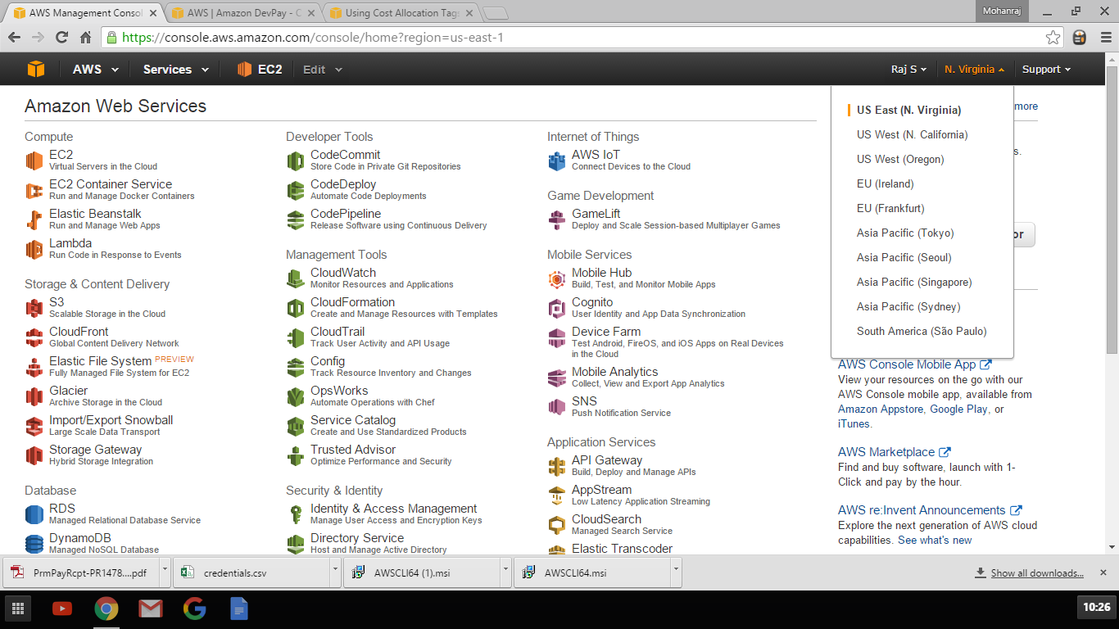

Click Support center to create support ticket to AWS

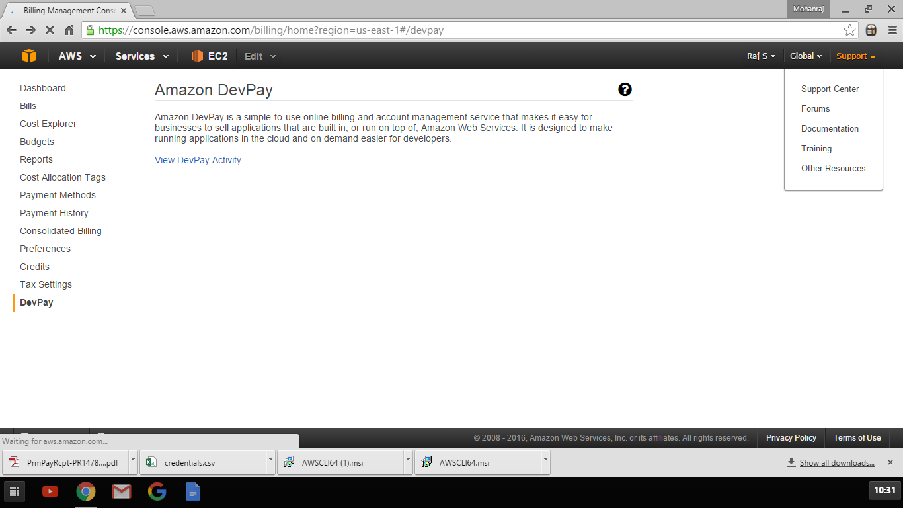

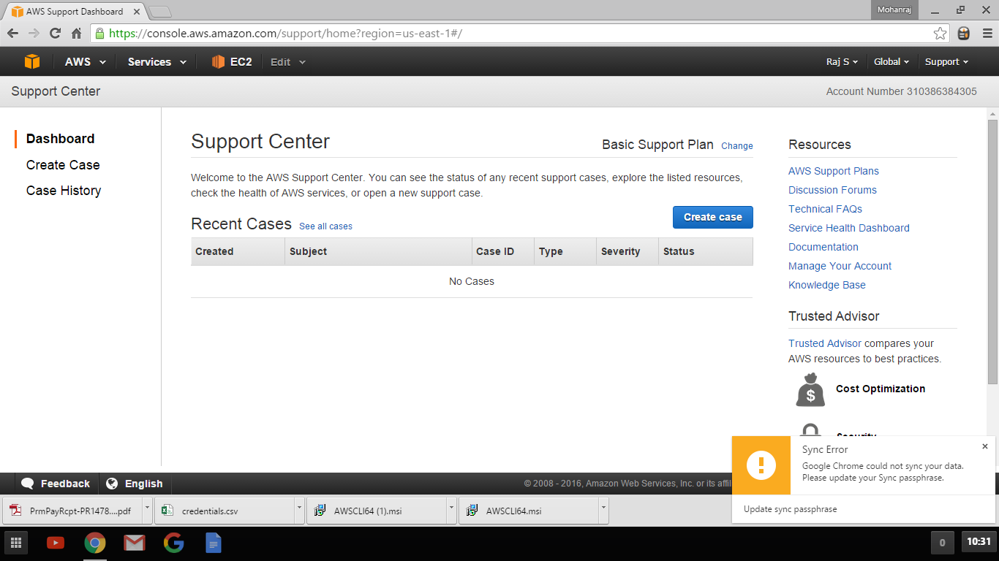

Click Forum to enter to AWS Services Discussion Forum

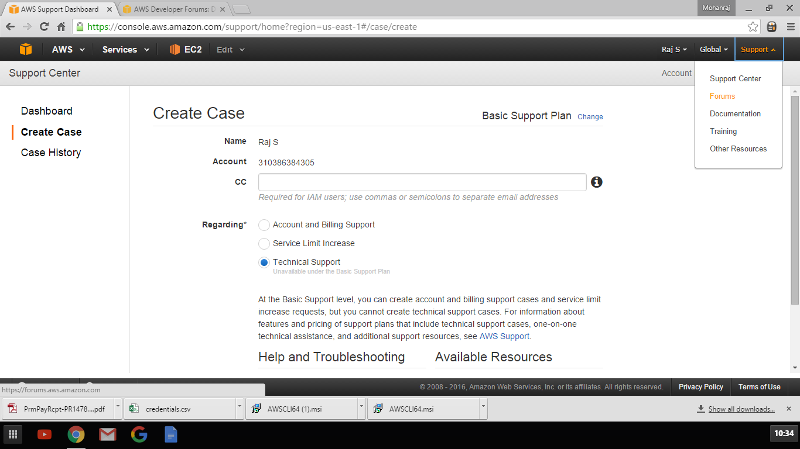

Click on Documentation to access AWS Documentation